CSC420 Assignment 2

Zhihong Wang

wangz154

1002095207

Q1.(a).

Code:

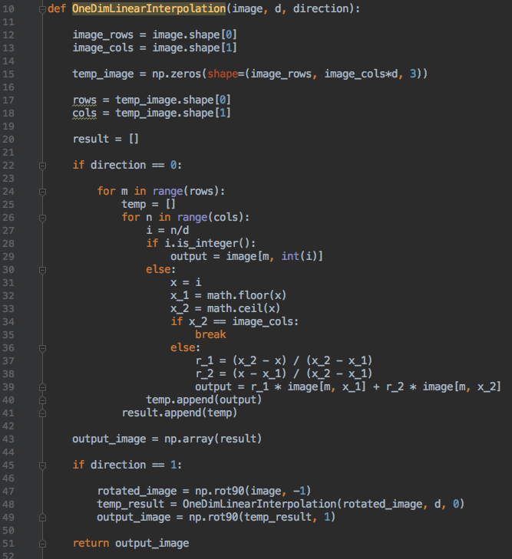

1D Final Result: 685 × 677

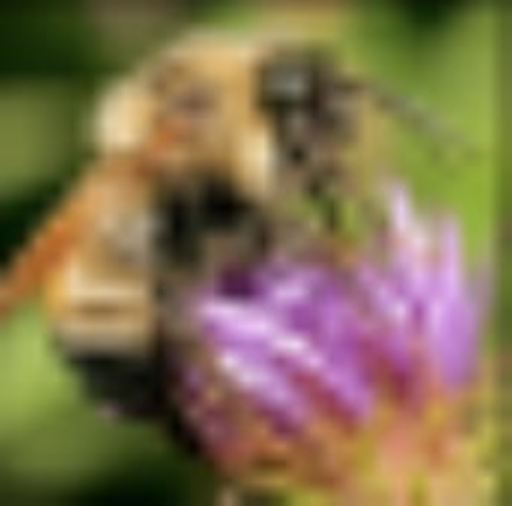

First, I applied 1D interpolation, horizontally, then vertically, the result is above. If you do vertically first, then horizontally, it will also lead to the same result.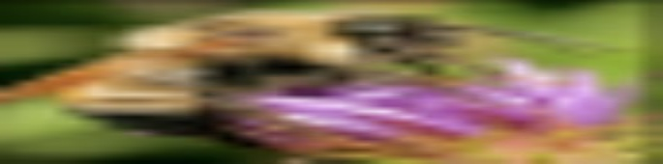

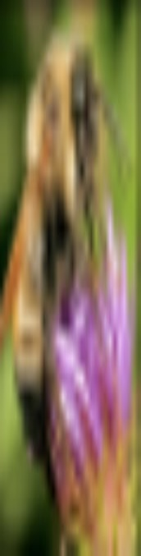

2D Final Result: 685 × 677



When d = 4 (quadruple), the filter is:

[[ 0. , 0. , 0. , 0. , 0. , 0. , 0. , 0. , 0. ],

[ 0. , 0.0625, 0.125 , 0.1875, 0.25 , 0.1875, 0.125 , 0.0625, 0. ],

[ 0. , 0.125 , 0.25 , 0.375 , 0.5 , 0.375 , 0.25 , 0.125 , 0. ],

[ 0. , 0.1875, 0.375 , 0.5625, 0.75 , 0.5625, 0.375 , 0.1875, 0. ],

[ 0. , 0.25 , 0.5 , 0.75 , 1. , 0.75 , 0.5 , 0.25 , 0. ],

[ 0. , 0.1875, 0.375 , 0.5625, 0.75 , 0.5625, 0.375 , 0.1875, 0. ],

[ 0. , 0.125 , 0.25 , 0.375 , 0.5 , 0.375 , 0.25 , 0.125 , 0. ],

[ 0. , 0.0625, 0.125 , 0.1875, 0.25 , 0.1875, 0.125 , 0.0625, 0. ],

[ 0. , 0. , 0. , 0. , 0. , 0. , 0. , 0. , 0. ]]

Q1.(b).

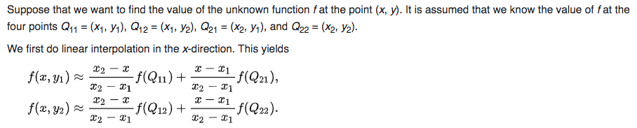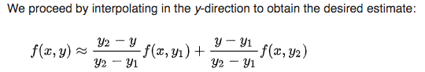

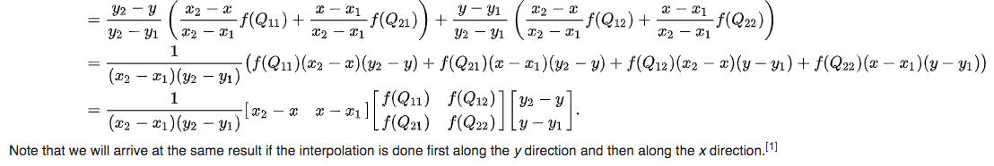

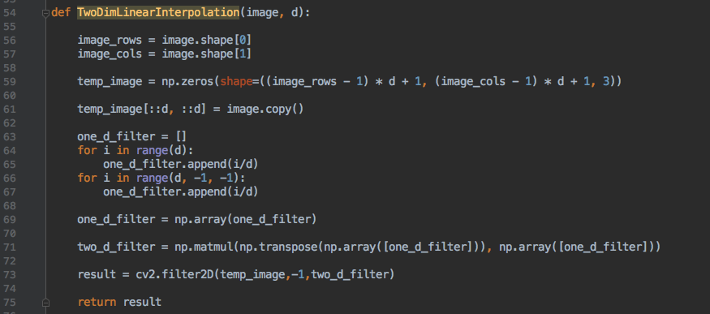

2D Final Result: 685 × 677



This result is the same as part (a).

Q2.(a).

Test:

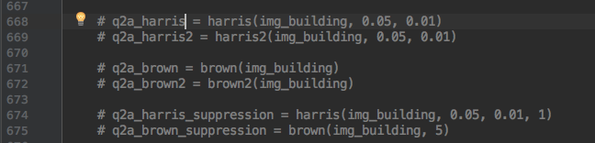

Harris:

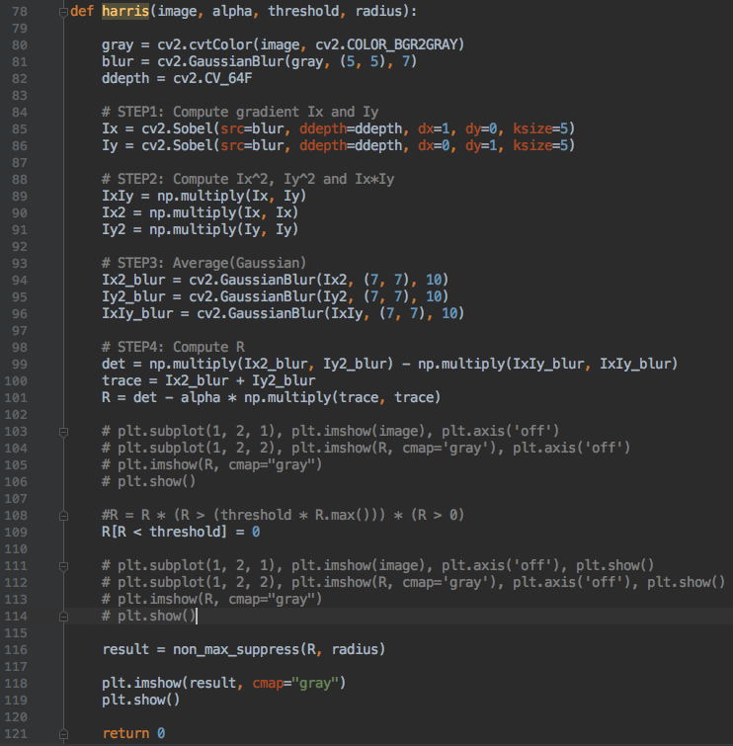

Harris Compare: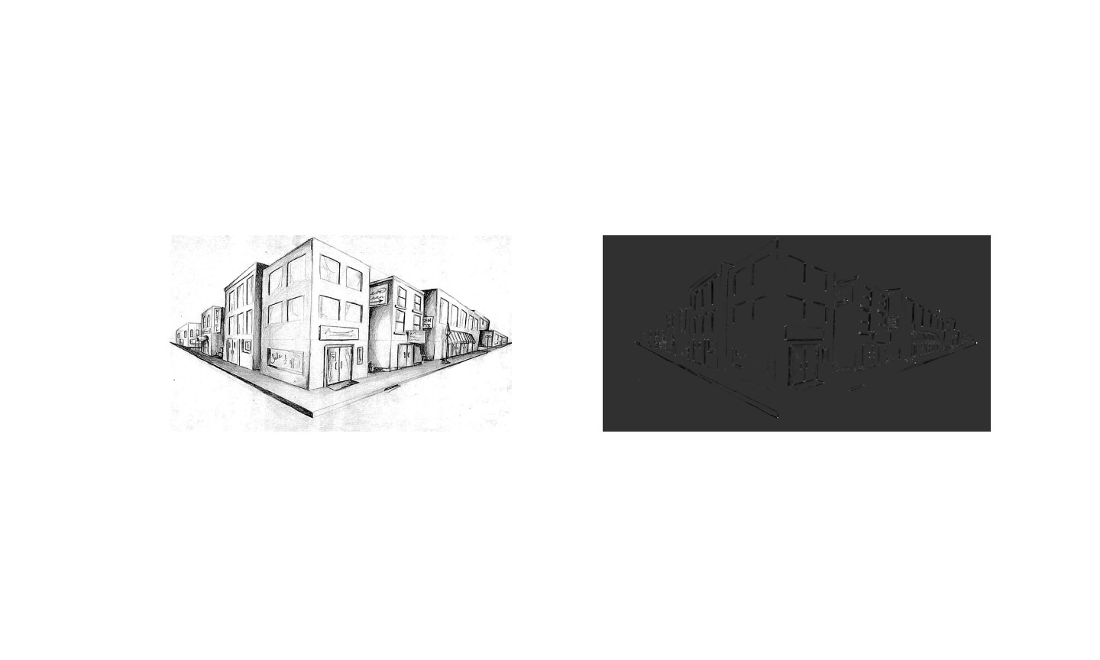

Harris Threshold:

Alpha = 0.01

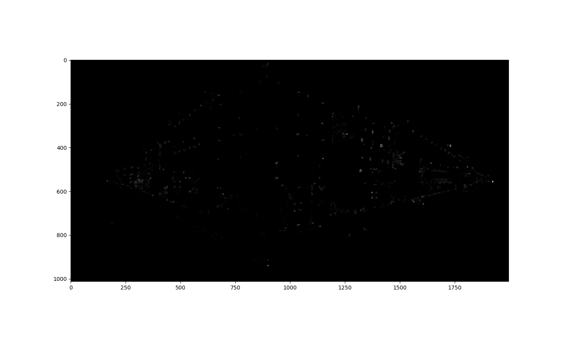

Alpha = 0.05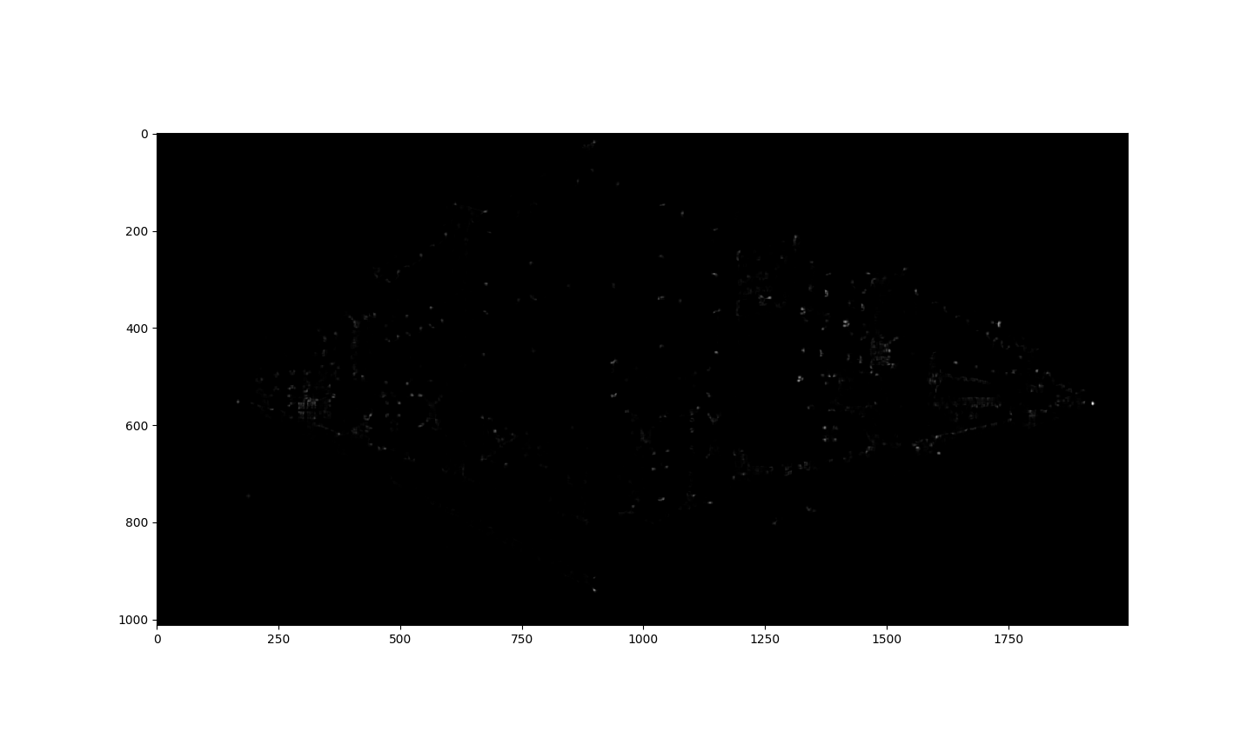

Alpha = 0.1



Harris Non-maximal Suppression:

Alpha = 0.01

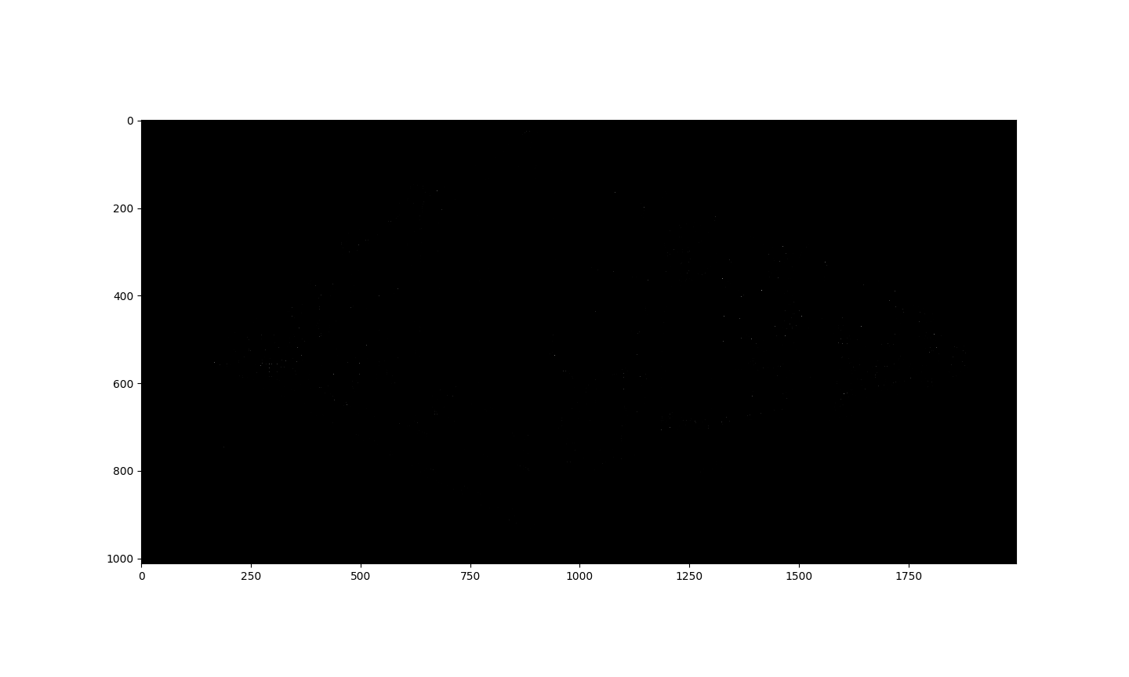

Alpha = 0.05

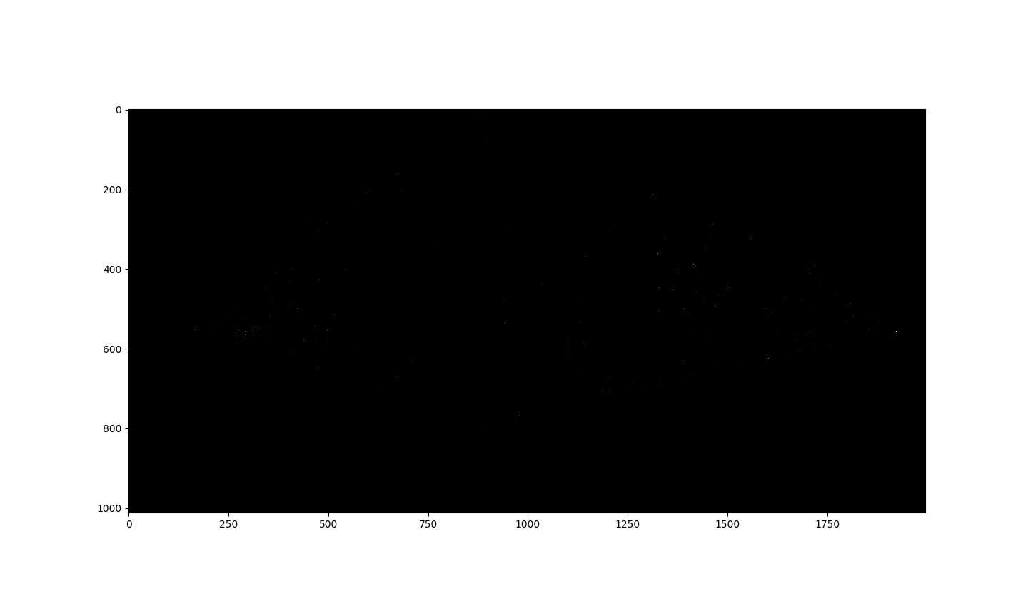

Alpha = 0.1

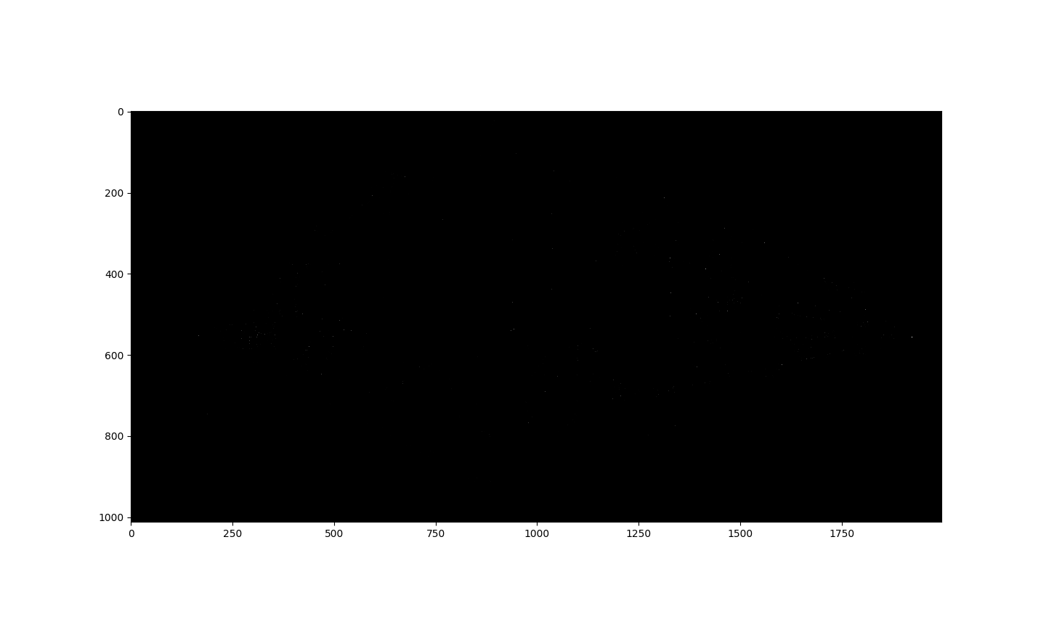

There is no big difference of these when alpha increasing little by little, the corners is slightly clearer.

Brown:

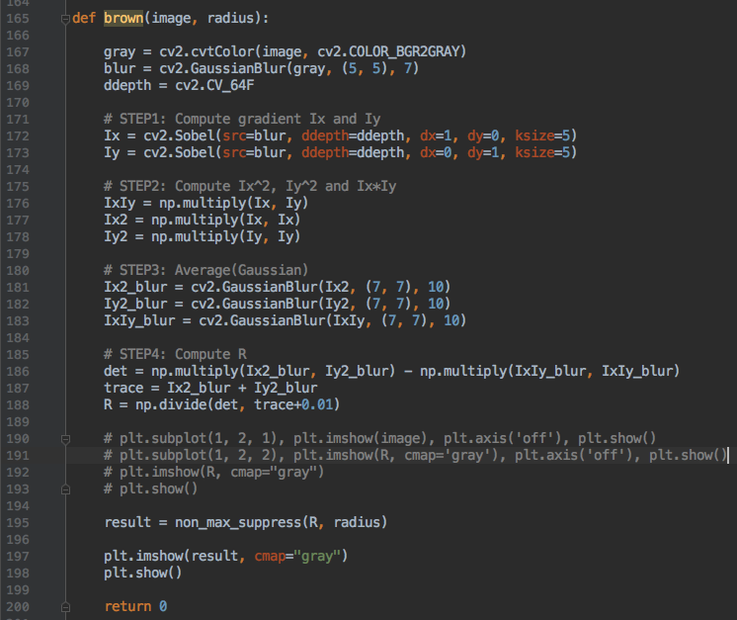

Brown Threshold:

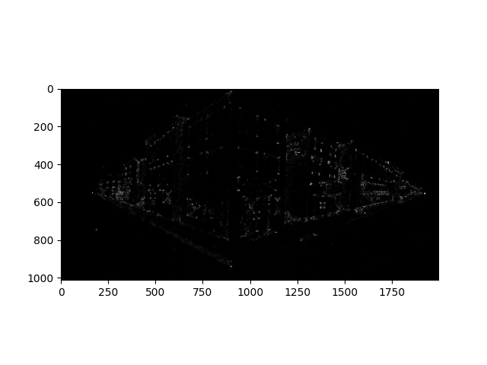

Brown non-maximal Suppression:

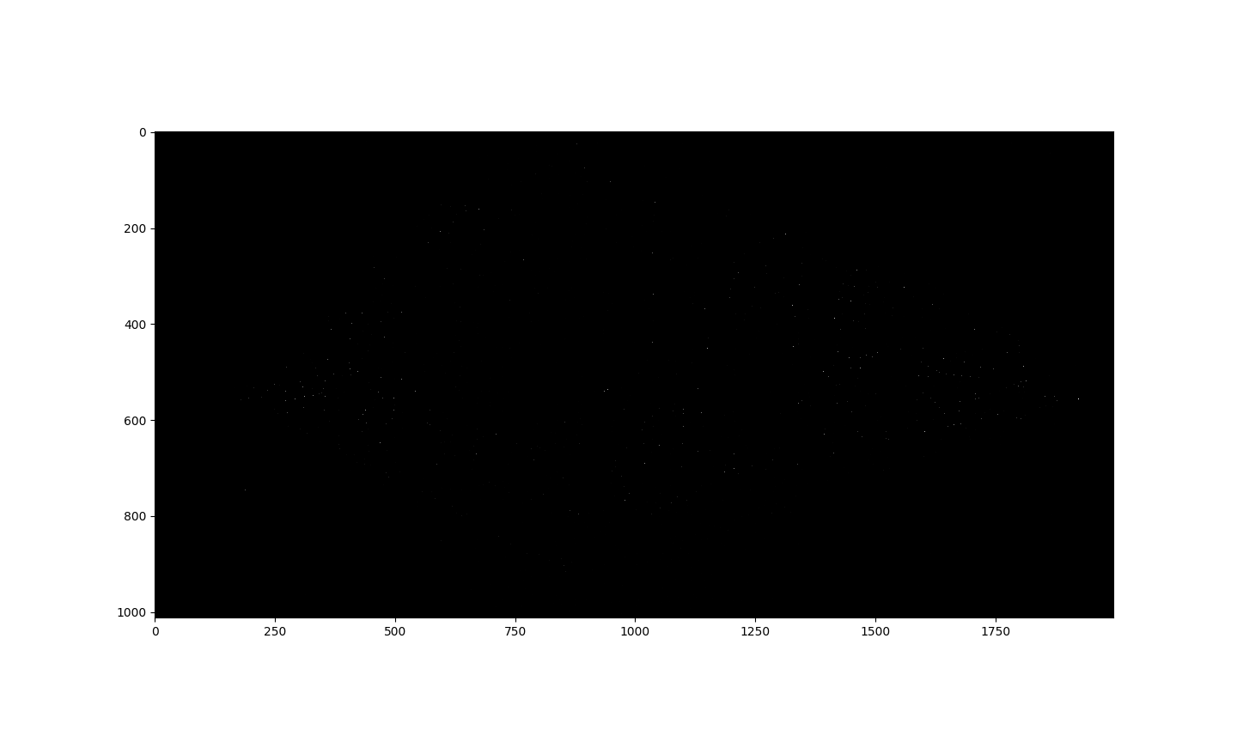

Harris without det and trace:

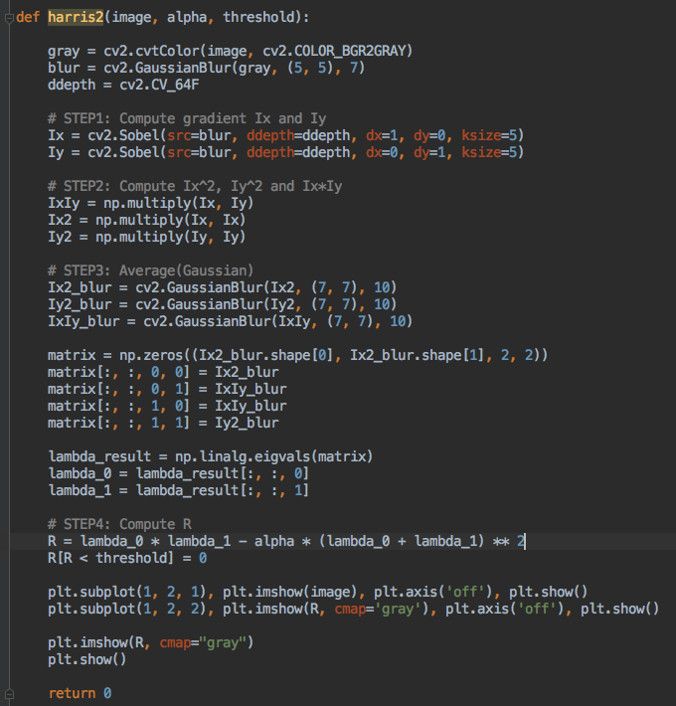

Brown without det and trace:

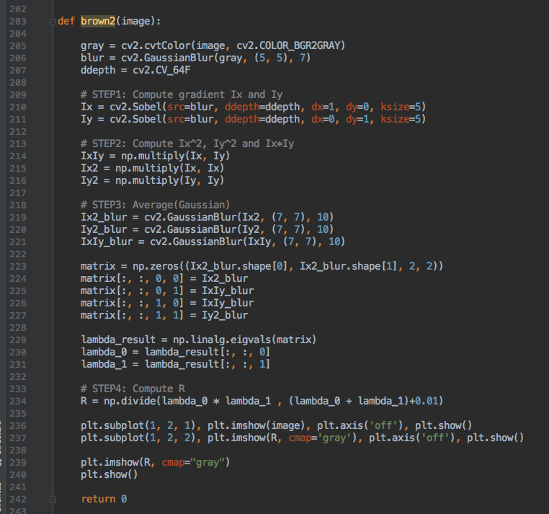

Q2.(b).

Rotated 60 degree:

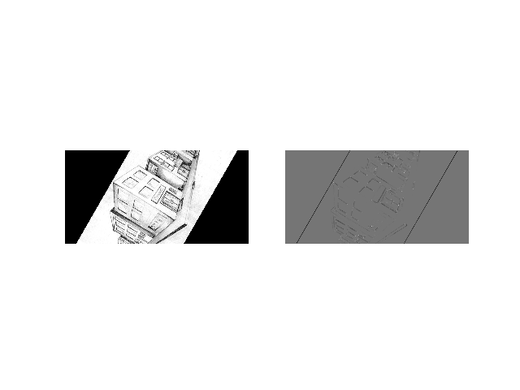

Rotated Threshold:

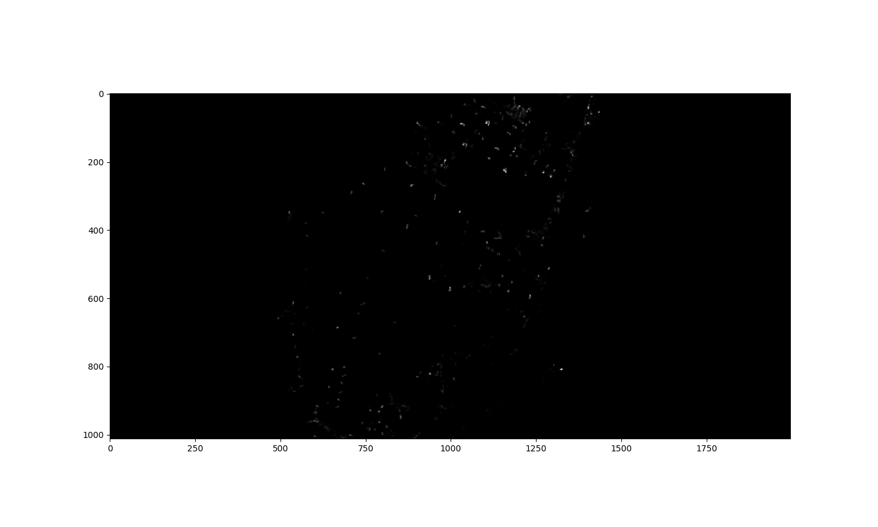

Rotated Non-maximal Suppression:

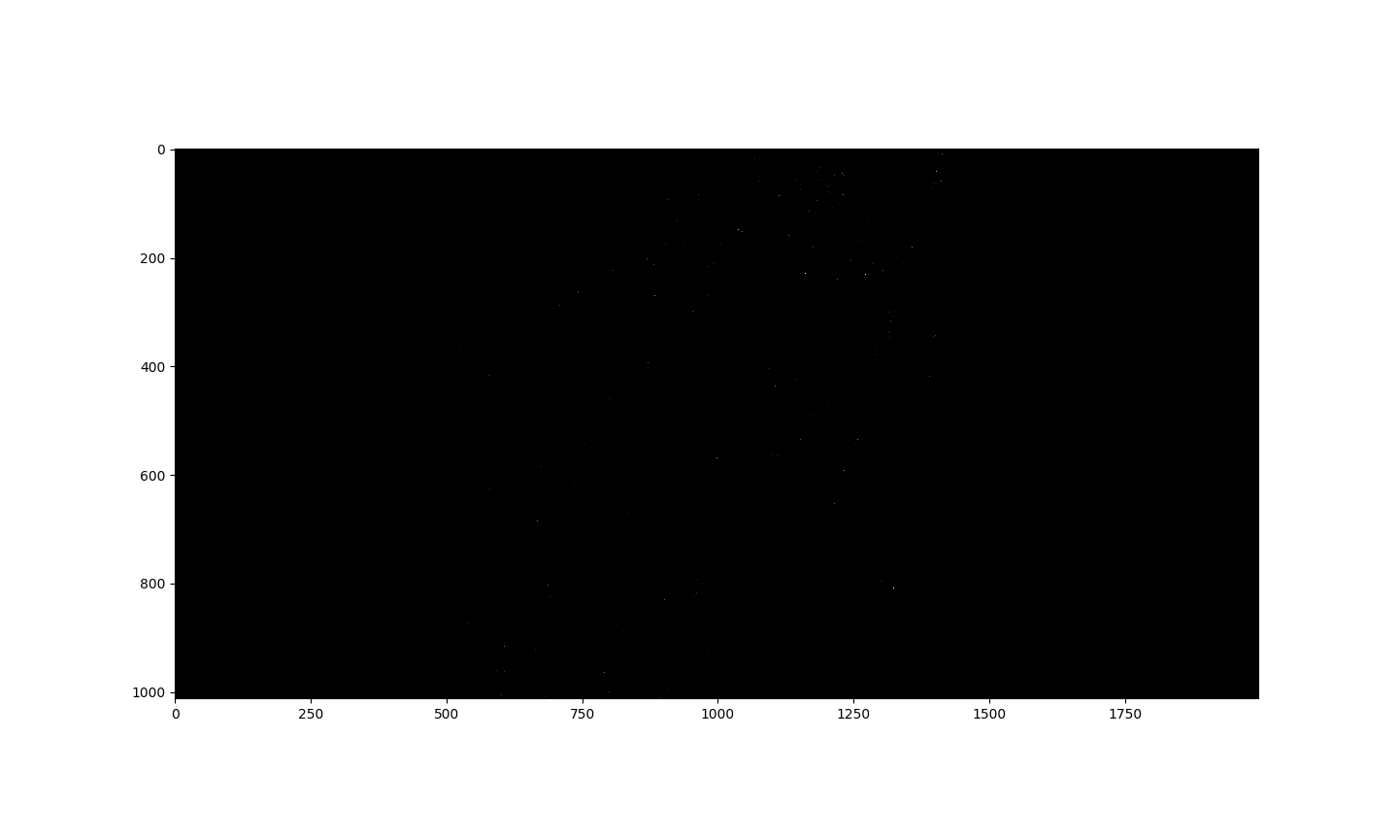

By observation, we can see the same corners can be still detected. Harris is rotation invariant because Second moment ellipse rotates but its shape (i.e. eigenvalues) remains the same.

Q2.(c).

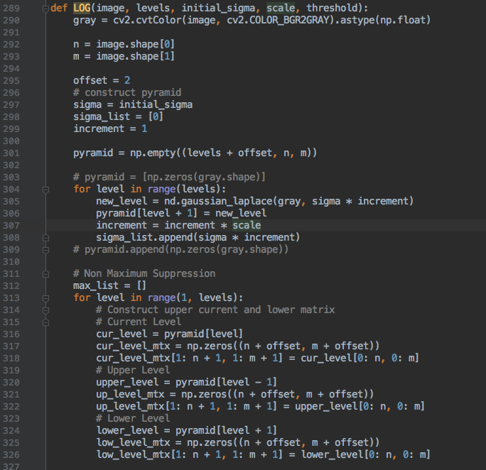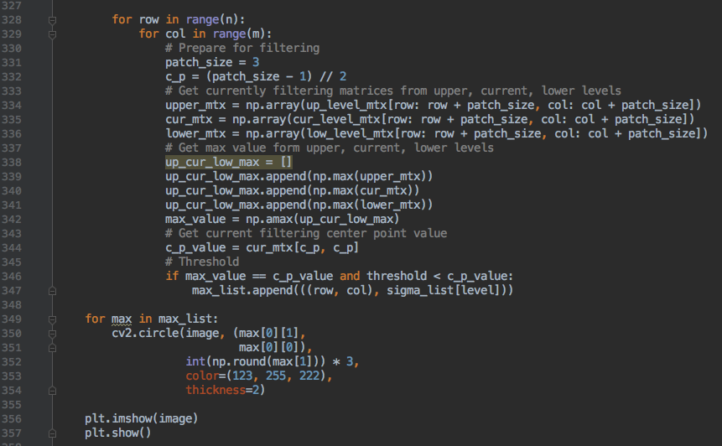



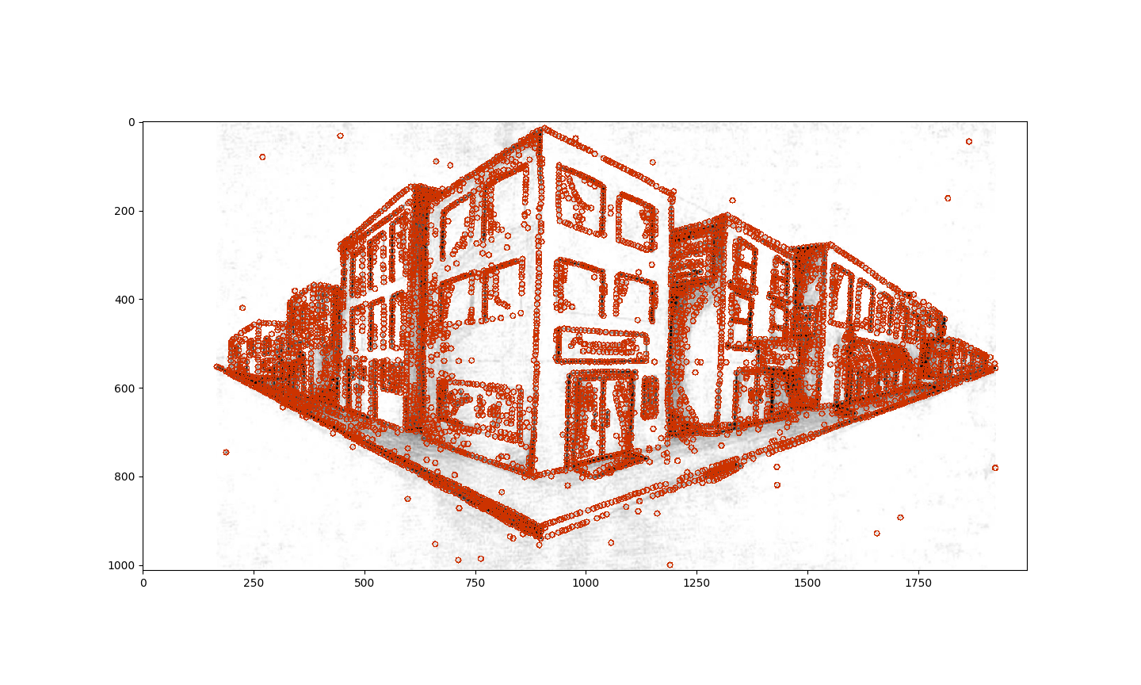

Q2.(d).

SURF detector: SURF stands for Speeded Up Robust Features which is inspired by SIFT and approaches corner detection via Laplacian of Gaussian. SURF uses an integer approximation of the determinant of Hessian blob detector using the precomputed integral image:

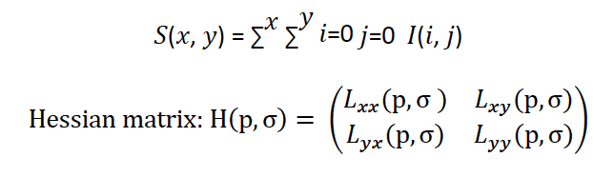

The determinant of the Hessian matrix is evaluated as the measurement of the local changes around the point. For non-maximum suppression, choose the point with maximum determinant of Hessian in its neighbor as the key-point.

In SIFT, Lowe approximated Laplacian of Gaussian with Difference of Gaussian for finding scale-space. SURF goes a little further and approximates LoG with Box Filter. Below image shows a demonstration of such an approximation. One big advantage of this approximation is that, convolution with box filter can be easily calculated with the help of integral images. And it can be done in parallel for different scales. Also the SURF rely on determinant of Hessian matrix for both scale and location.

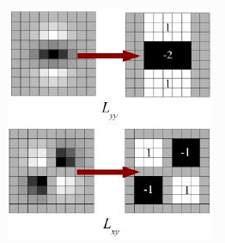

The creation of SURF descriptor takes place in two steps. The first step consists of fixing a reproducible orientation based on information from a circular region around the keypoint. Then, we construct a square region aligned to the selected orientation and extract the SURF descriptor from it.

1. Surf first calculate the Haar-wavelet responses in x and y-direction, and this in a circular neighborhood of radius 6s around the keypoint, with s the scale at which the keypoint was detected. Also, the sampling step is scale dependent and chosen to be s, and the wavelet responses are computed at that current scale s. Accordingly, at high scales the size of the wavelets is big. Therefore integral images are used again for fast filtering.
2. Then we calculate the sum of vertical and horizontal wavelet responses in a scanning area, then change the scanning orientation (add π/3), and re-calculate, until we find the orientation with largest sum value, this orientation is the main orientation of feature descriptor.
3. The first step consists of constructing a square region centered around the keypoint and oriented along the orientation we already got above. The size of this window is 20s.
4. Then the region is split up regularly into smaller 4 × 4 square sub-regions. For each sub-region, we compute a few simple features at 5×5 regularly spaced sample points. For reasons of simplicity, we call **dx** the Haar wavelet response in the horizontal direction and **dy** the Haar wavelet response in the vertical direction (filter size 2s). To increase the robustness towards geometric deformations and localization errors, the responses dx and **dy** are first weighted with a Gaussian (σ = 3.3s) centered at the keypoint.

Then, the wavelet responses **dx** and **dy** are summed up over each subregion and form a first set of entries to the feature vector. In order to bring in information about the polarity of the intensity changes, we also extract the sum of the absolute values of the responses, **|dx|** and **|dy|**. Hence, each sub-region has a four-dimensional descriptor vector v for its underlying intensity structure**V .** This results in a descriptor vector for all 4×4 sub-regions of **length 64** (In **Sift**, our descriptor is the **128-D vector**, so this is part of the reason that SURF is faster than Sift).

Q3.(a).

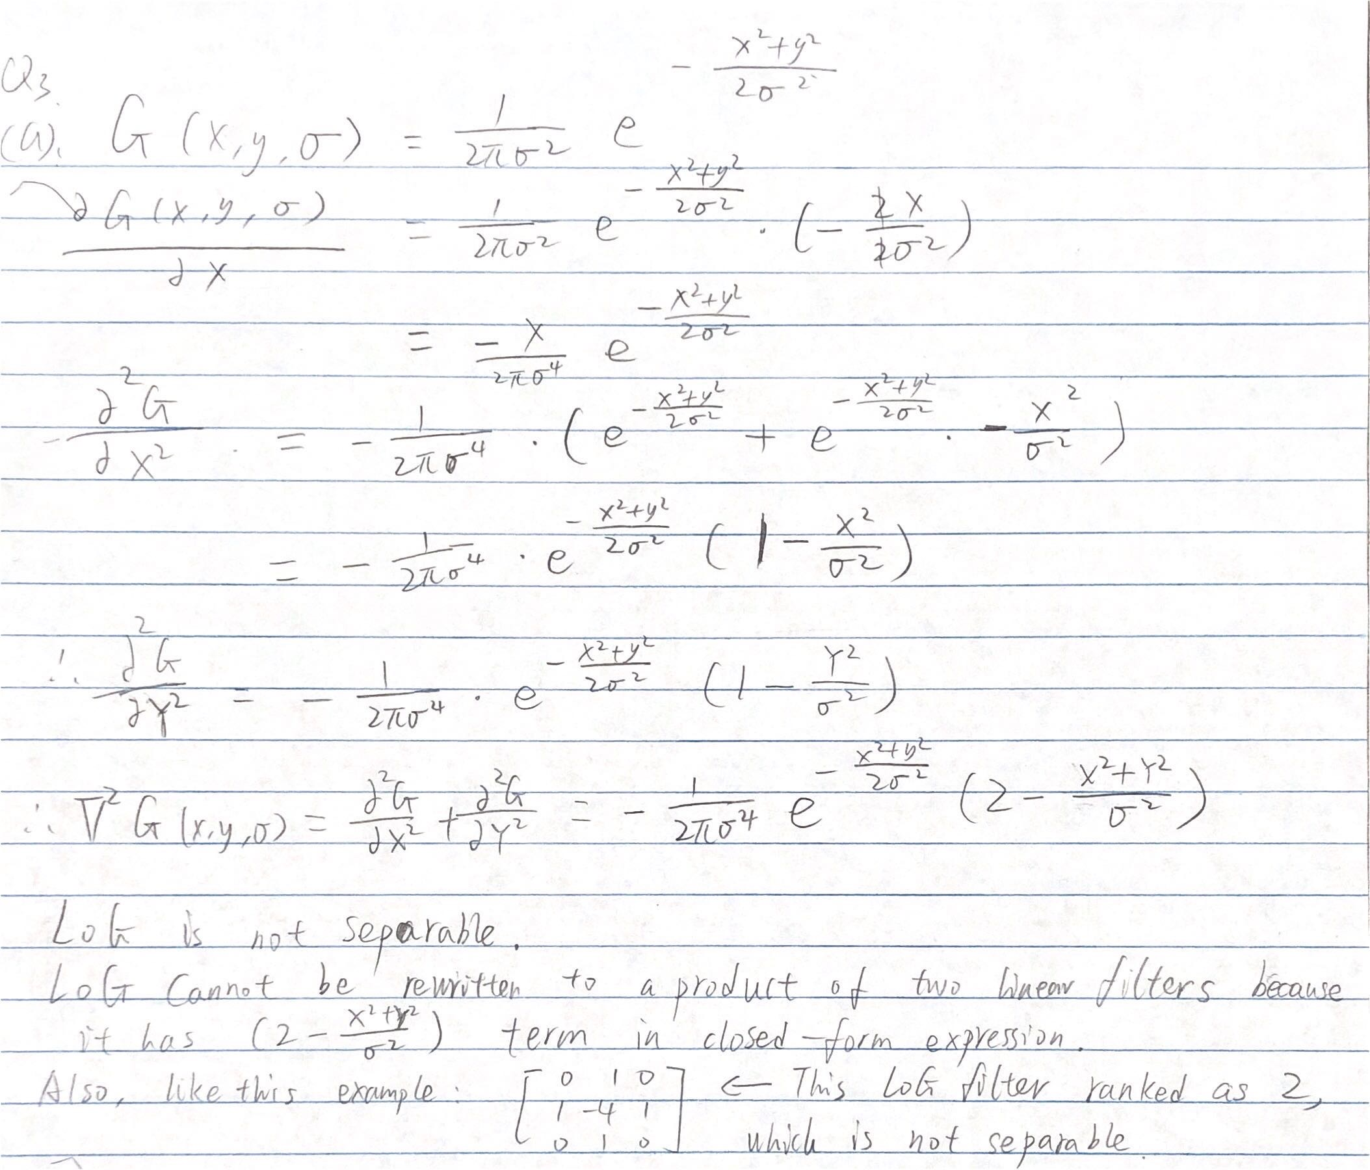

Q3.(b).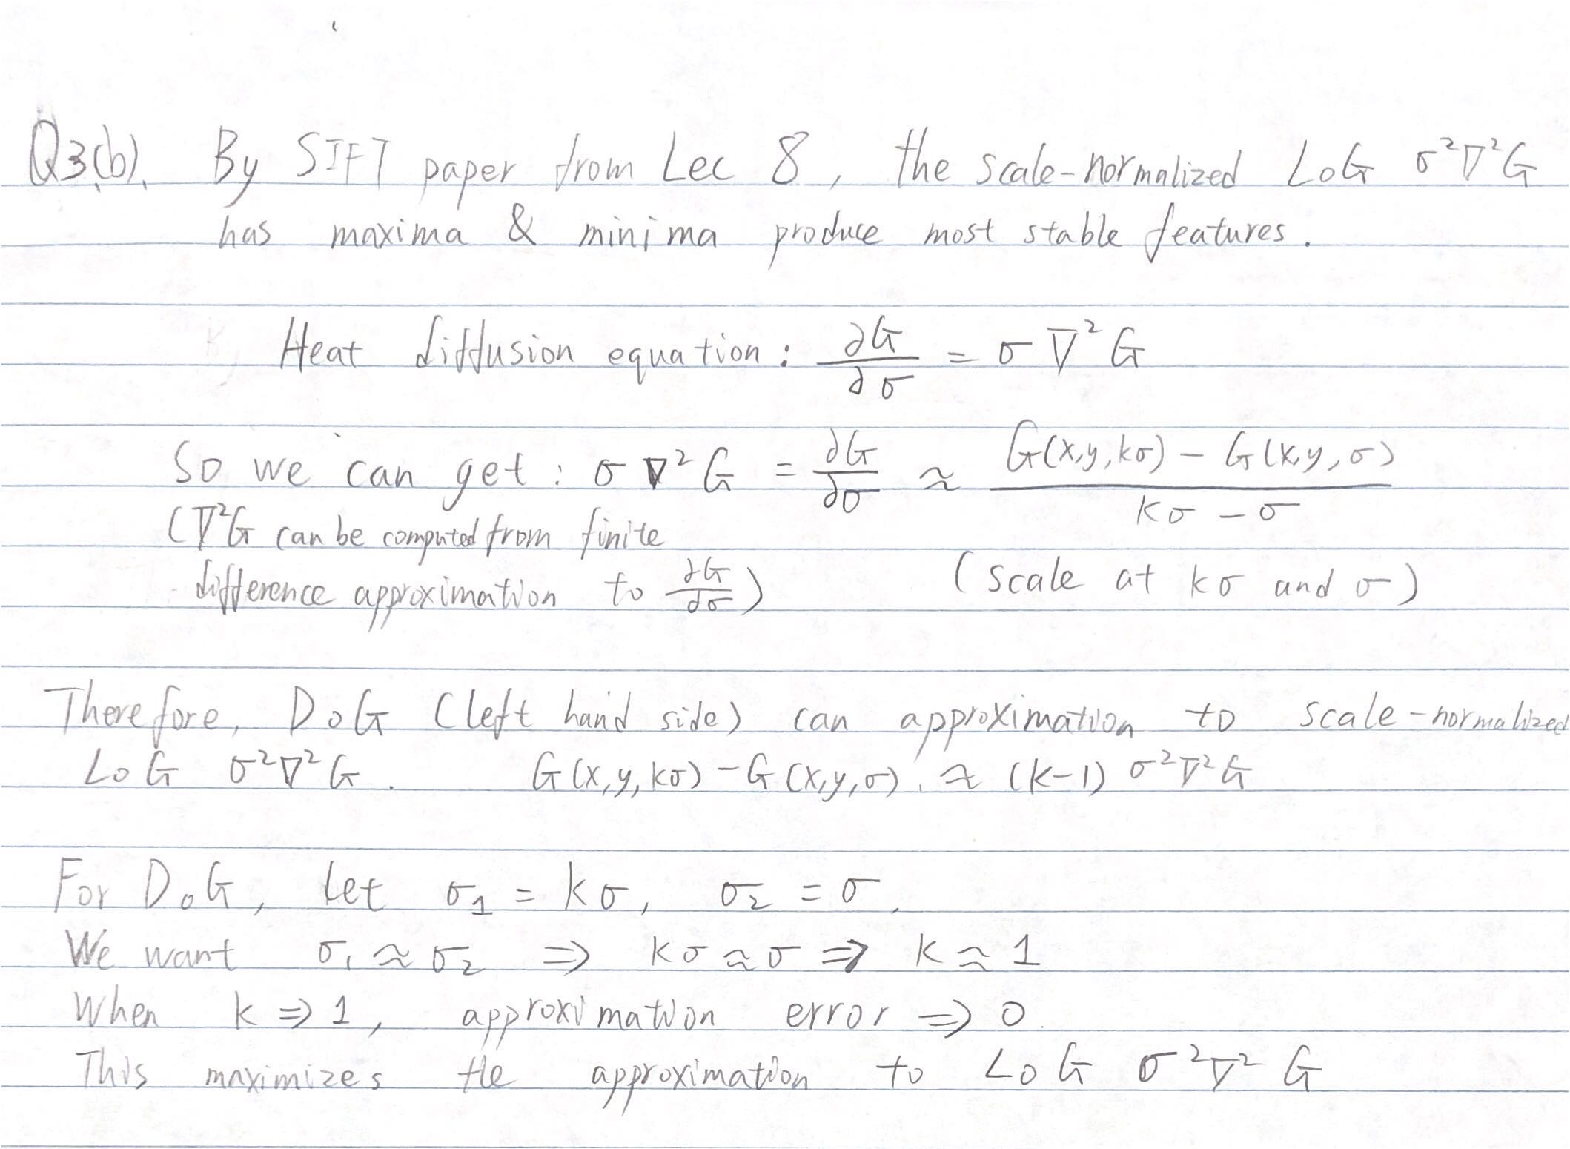

Q4.(a).

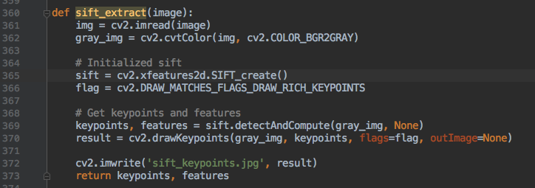

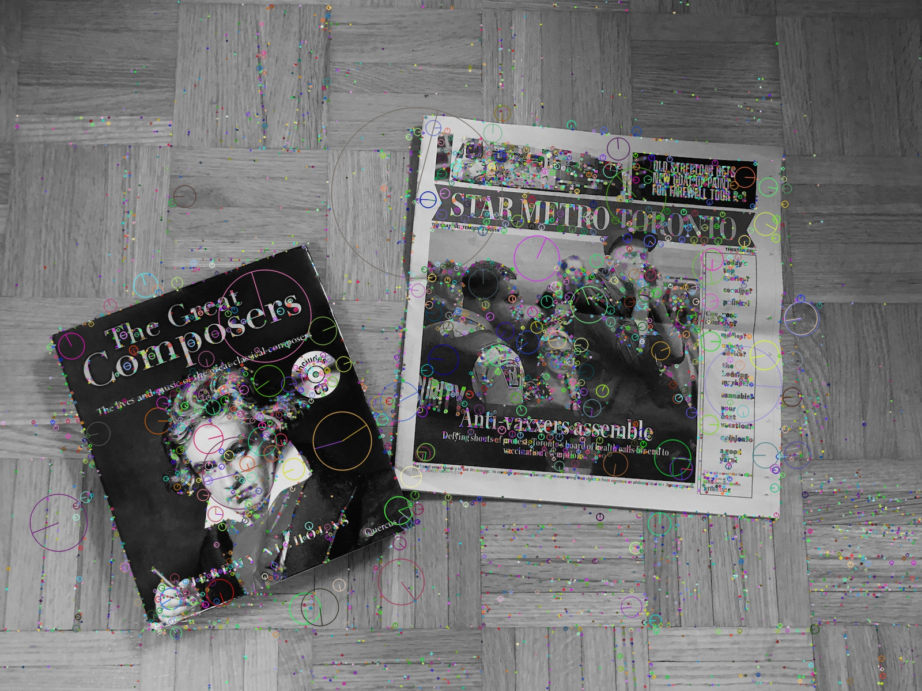

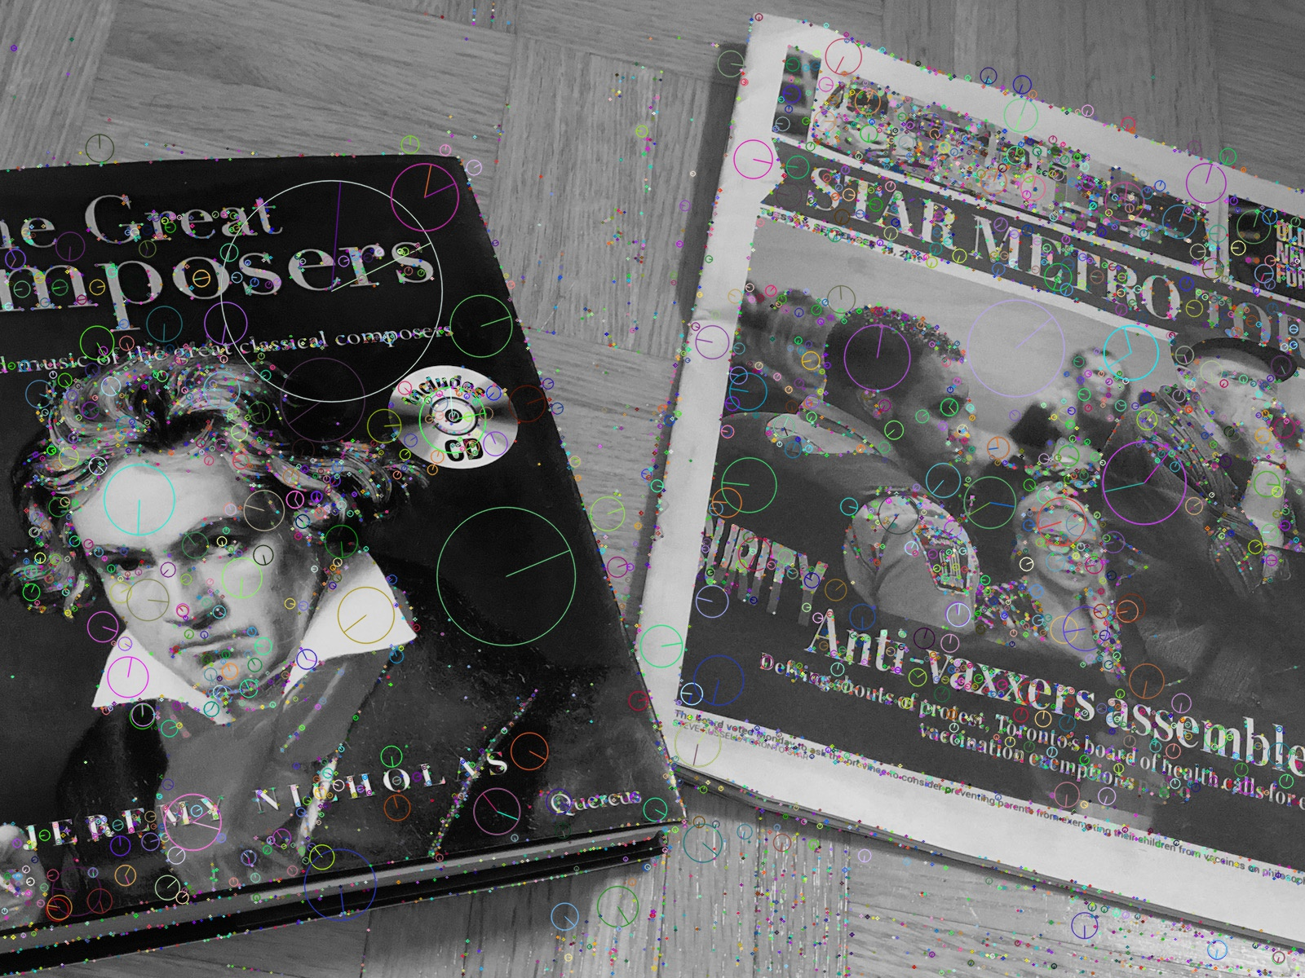

Q4.(b).

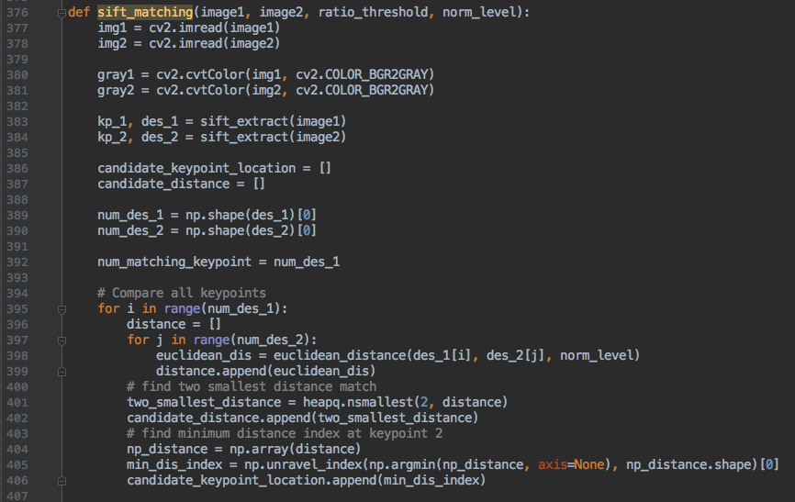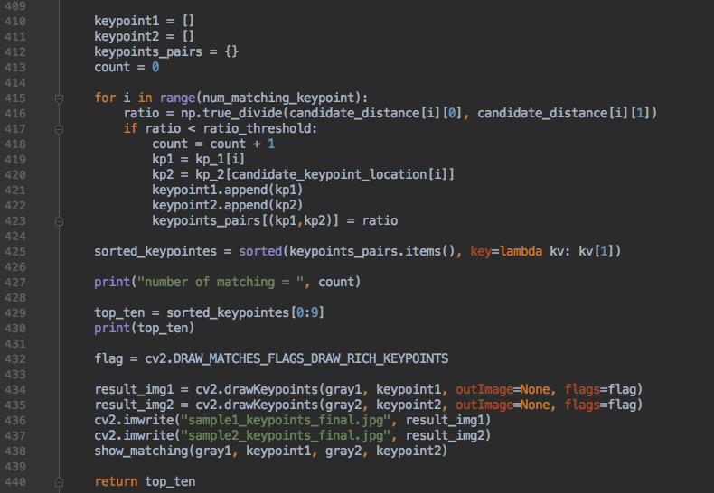

When norm level = 2, it is L2 norm:

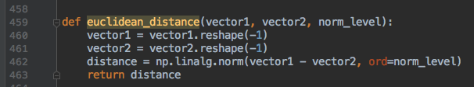

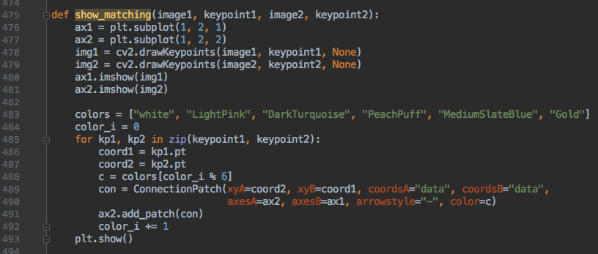

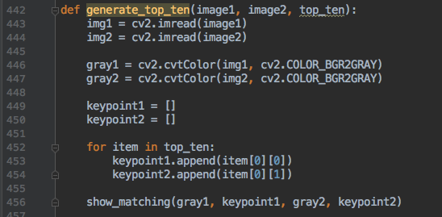

Results when threshold increasing:

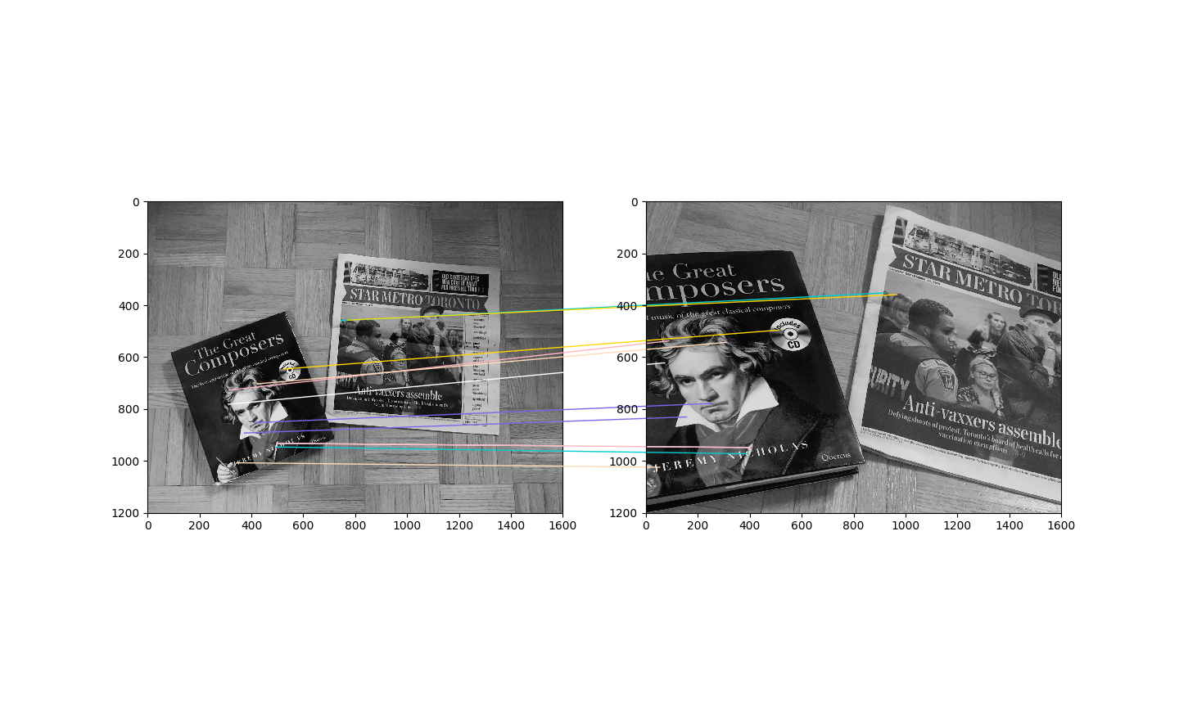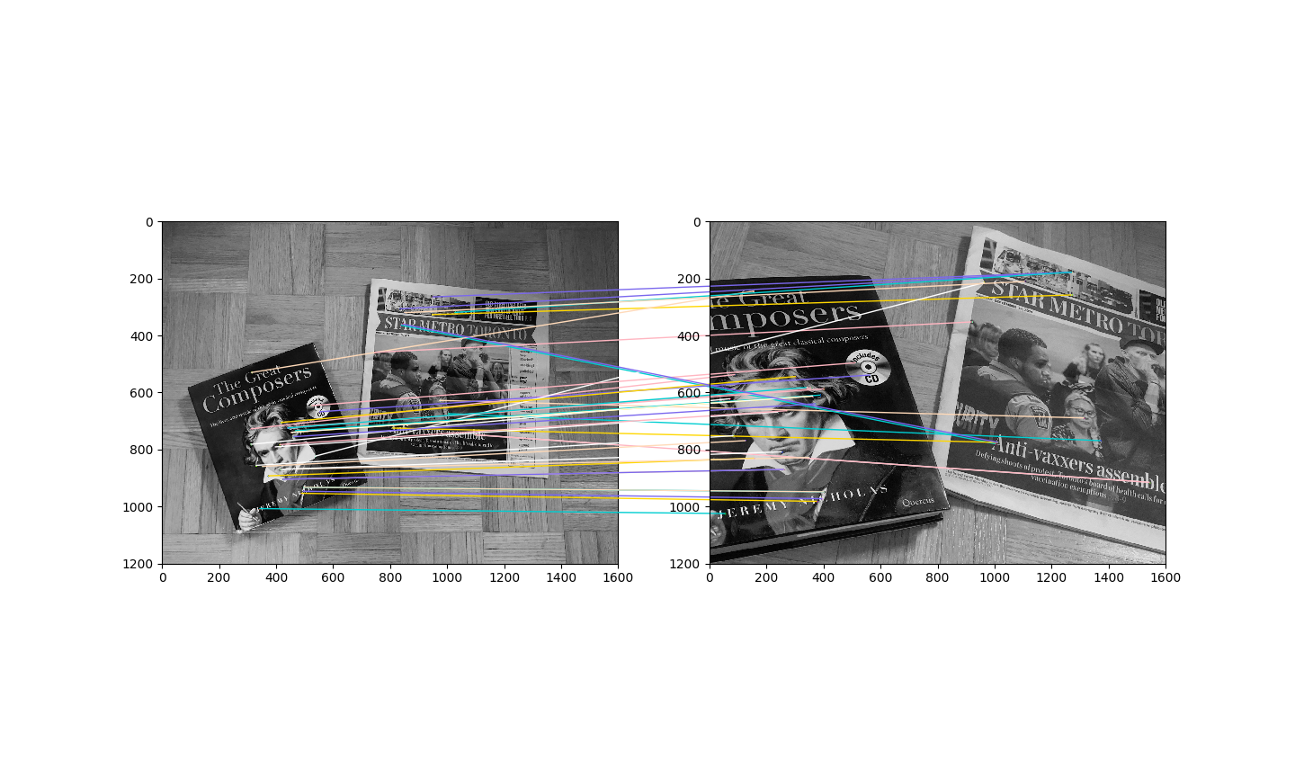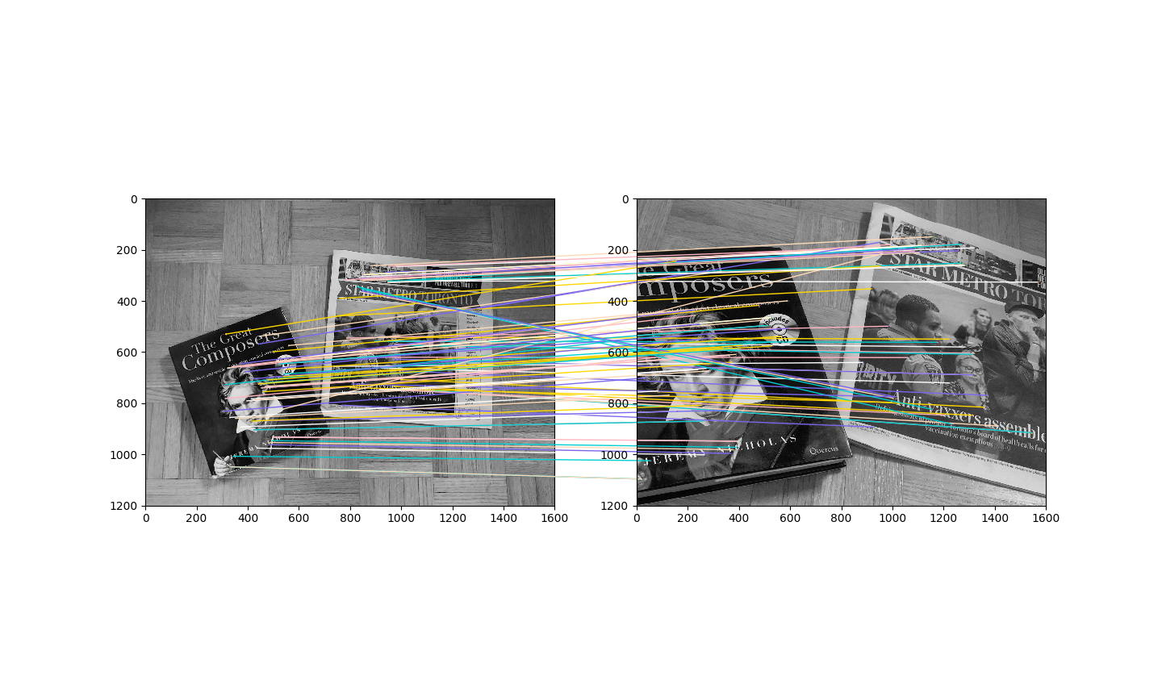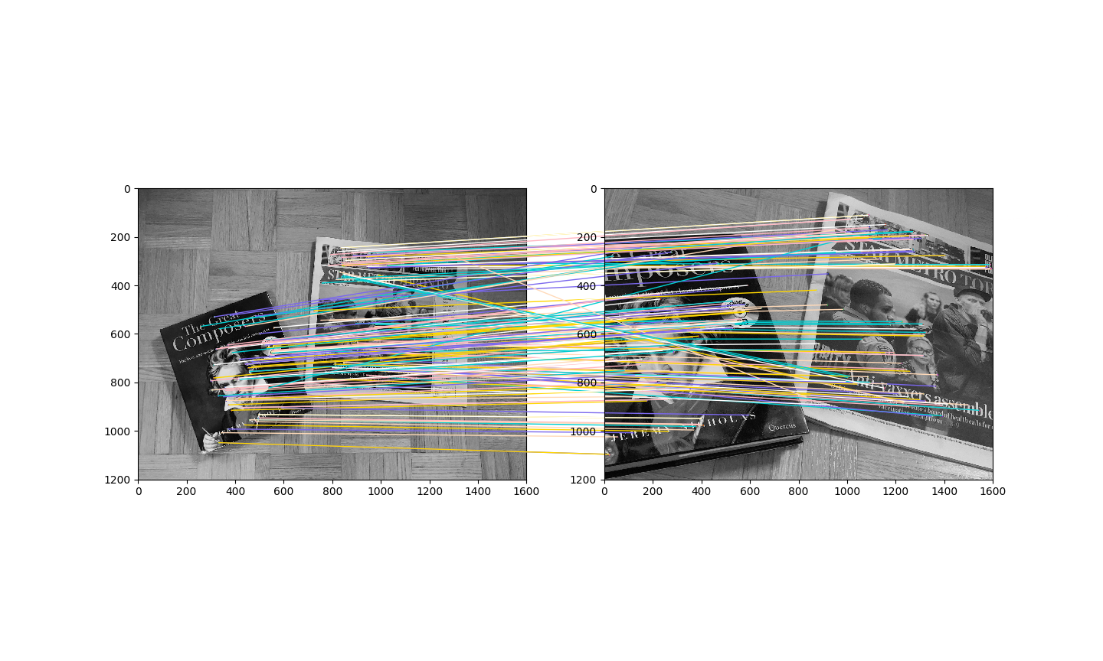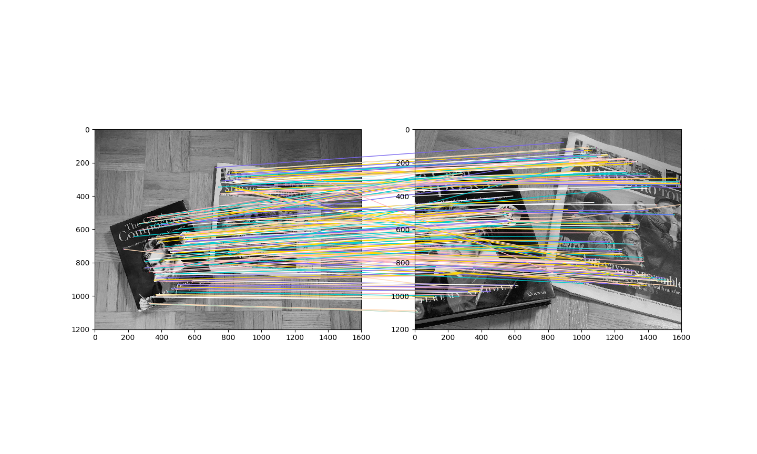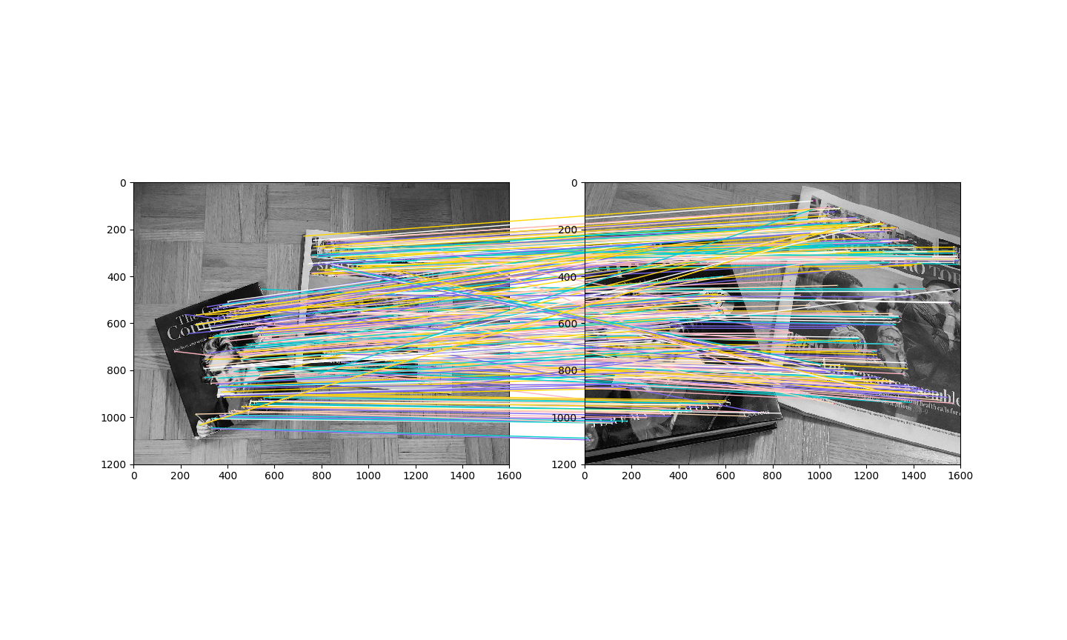

Number of Matches (Please know, since the code execution on my laptop is very long for Q4, to make sure I can finish this assignment on time, I set the limitation as 2000 during sift initialization so that the running can be faster. The results of number of matches and the matching will be slightly less powerful than normal setting. However, the tendency is the same.):

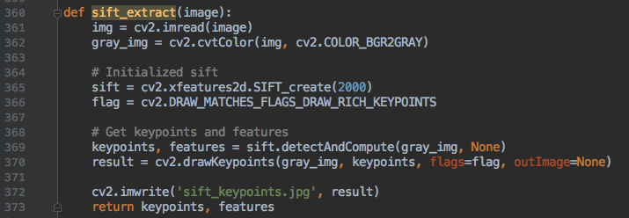

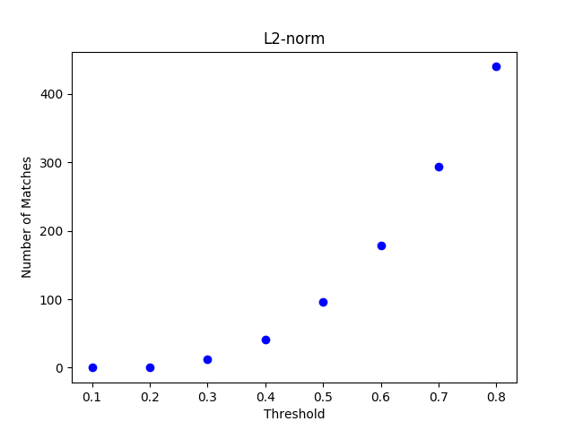

L2: Top 10 matches at best threshold 0.8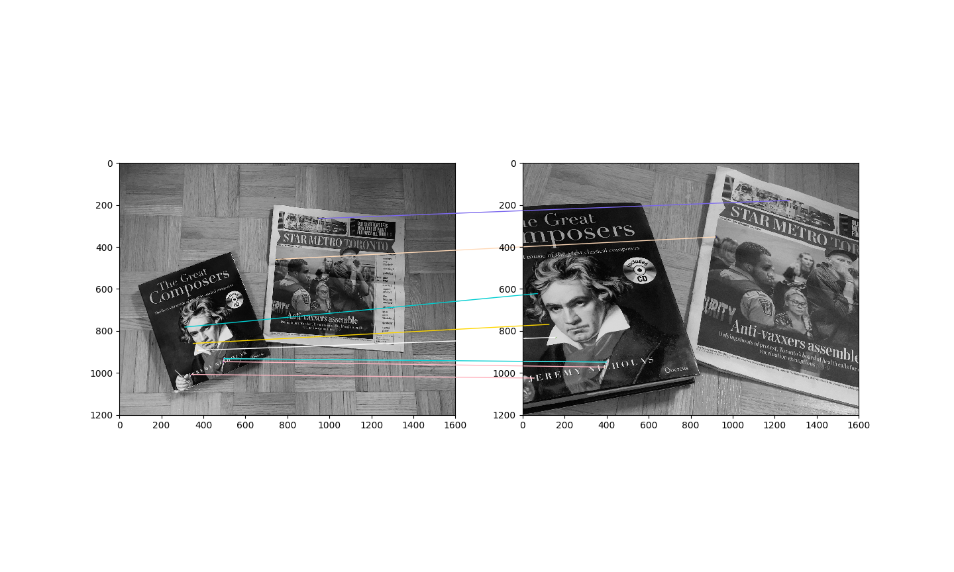

Q4.(c).

Number of Matches (Please know, since the code execution on my laptop is very long for Q4, to make sure I can finish this assignment on time, I set the limitation as 2000 during sift initialization so that the running can be faster. The results of number of matches and the matching will be slightly less powerful than normal setting. However, the tendency is the same.):

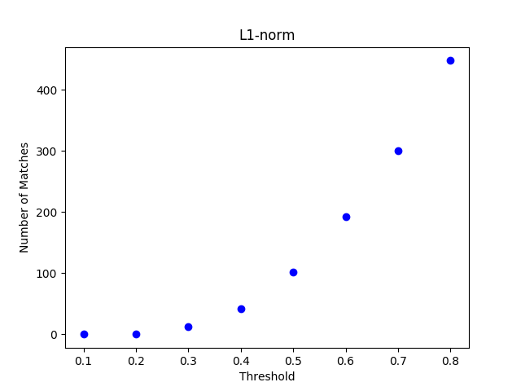

L1: Top 10 matches at best threshold 0.8:

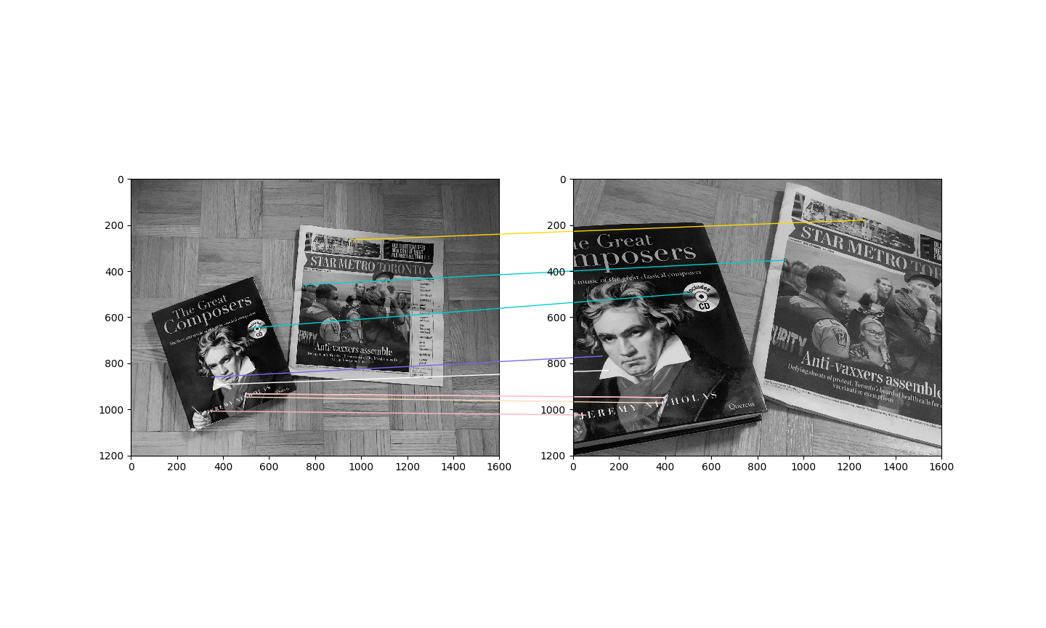

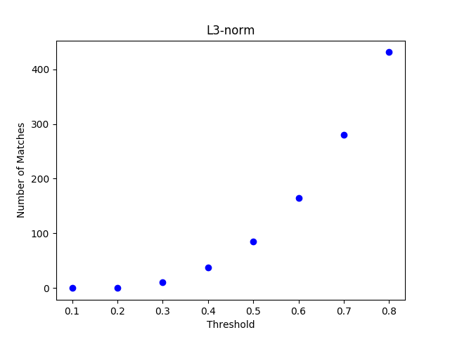

L3: Top 10 matches at best threshold 0.8:

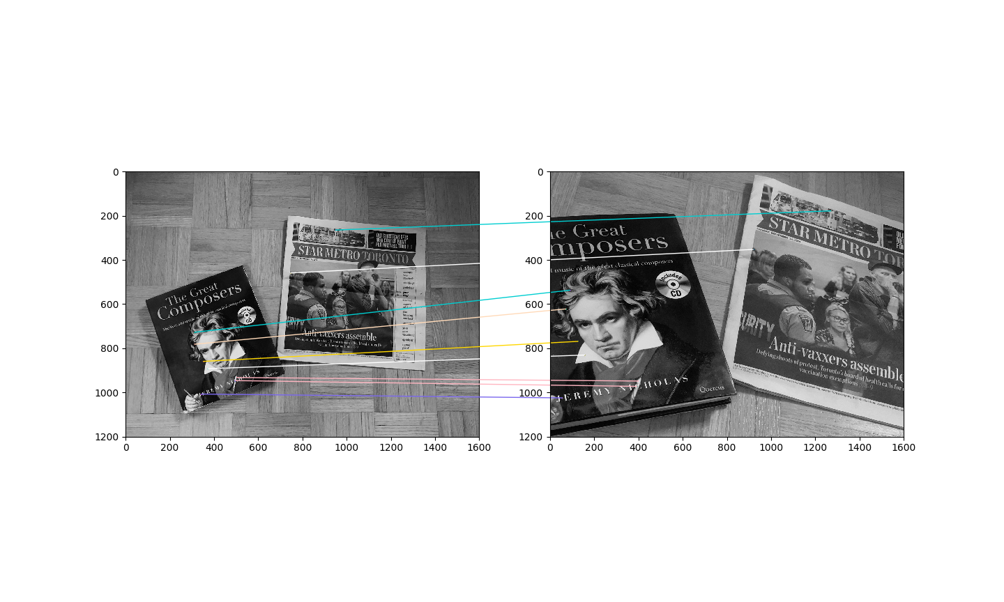

Based on the observation, there is no big difference among L1, L2, L3. We may need more pictures to actually find the differences under varied situations, however, I think the differences won’t be large.

Q4.(d).

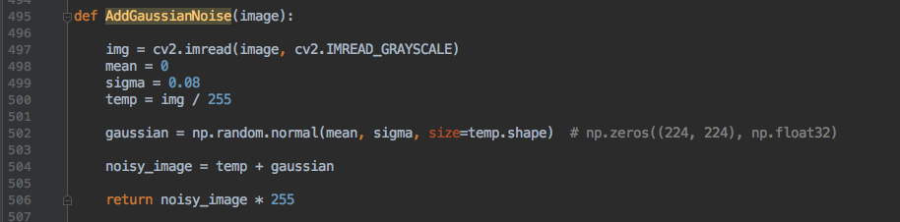

Added noises:

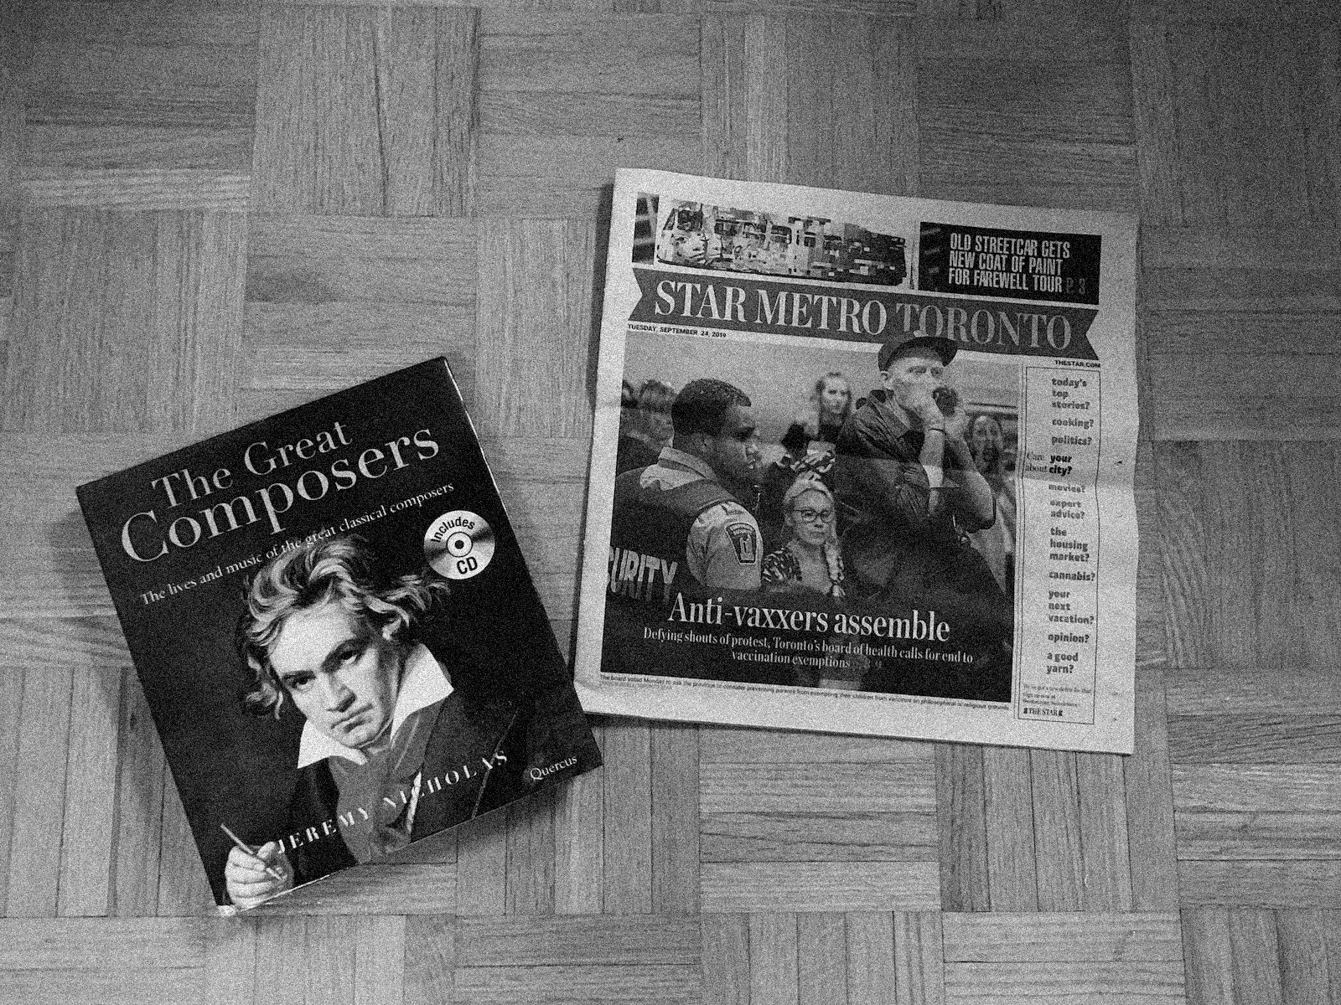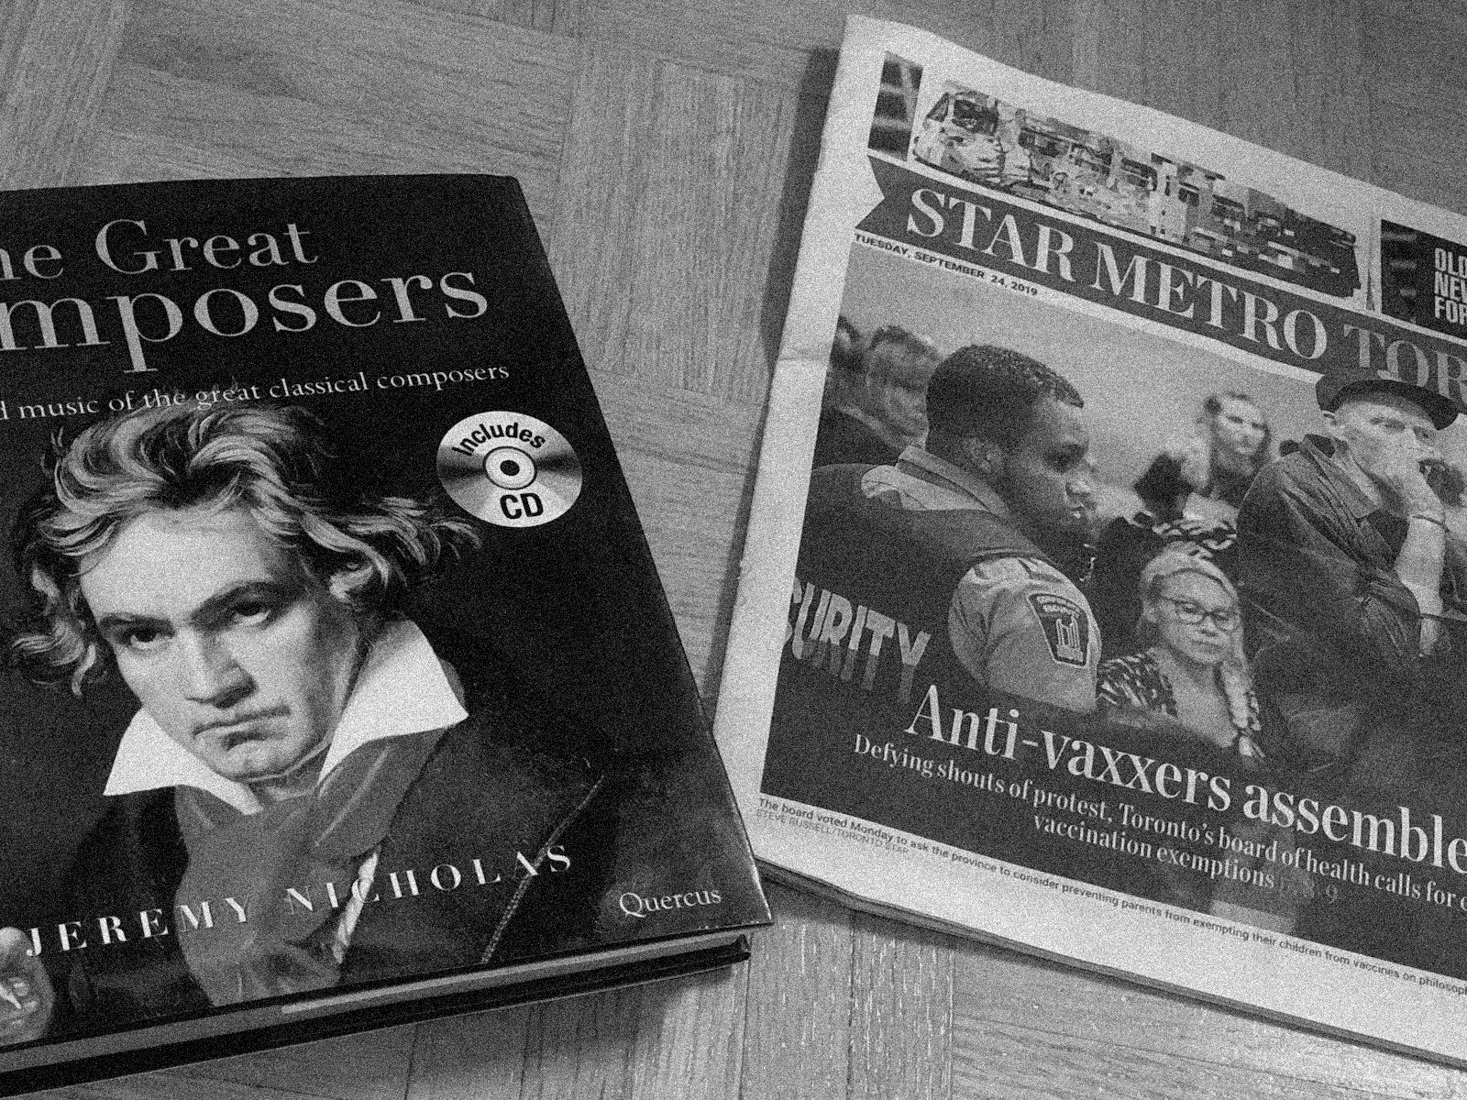

Extract SIFT keypoints:

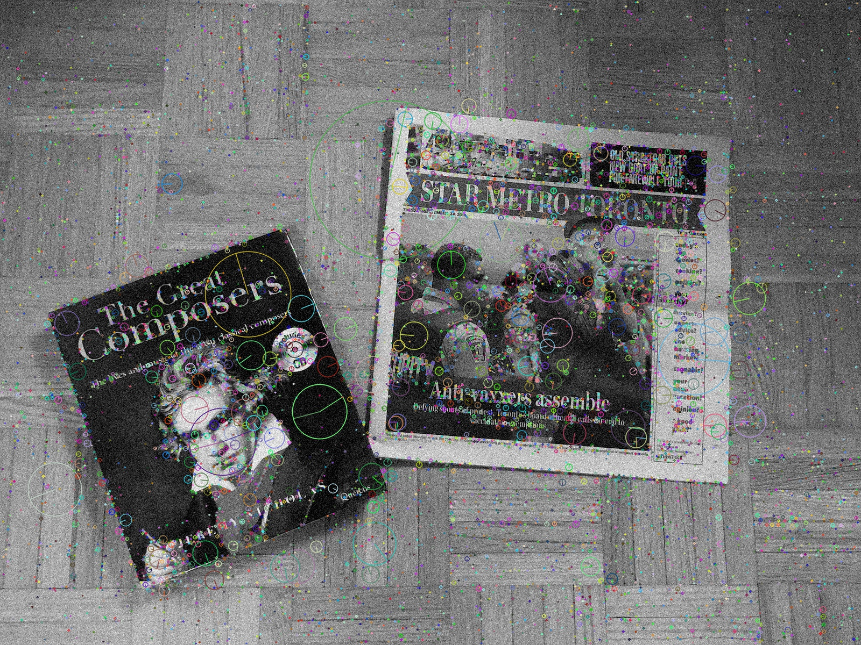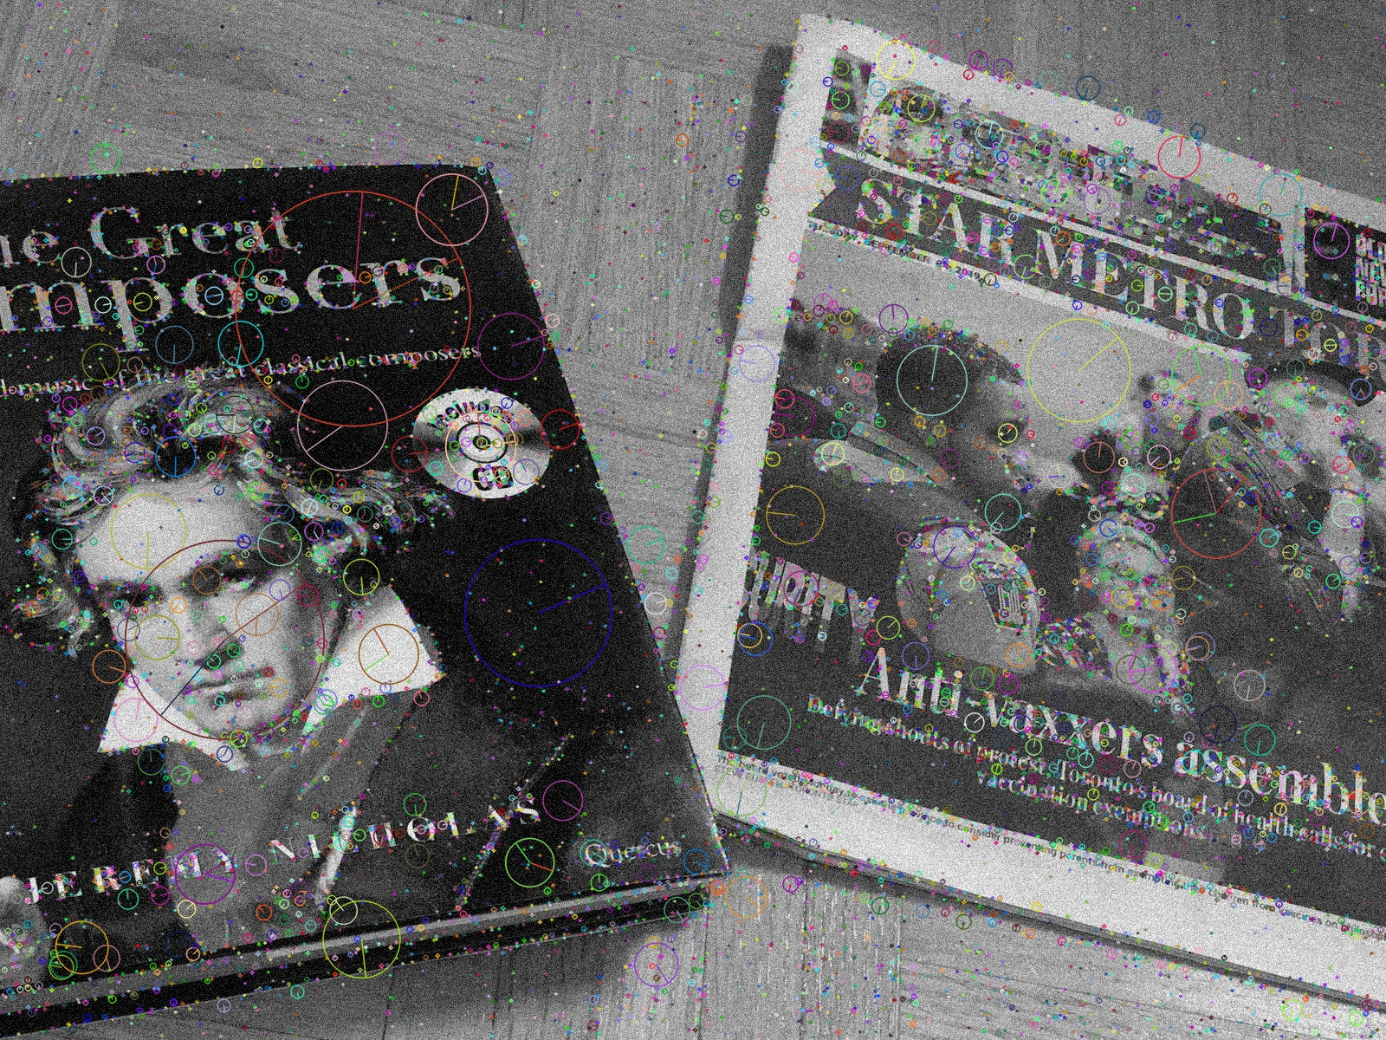

Number of Matches (Please know, since the code execution on my laptop is very long for Q4, to make sure I can finish this assignment on time, I set the limitation as 2000 during sift initialization so that the running can be faster. The results of number of matches and the matching will be slightly less powerful than normal setting. However, the tendency is the same.):

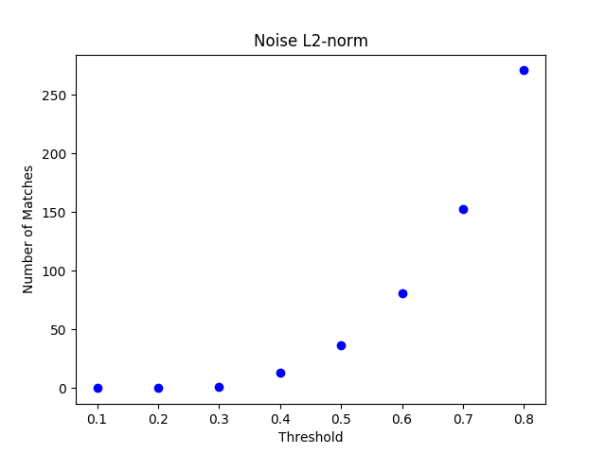

Top 10 matches at best threshold 0.8:

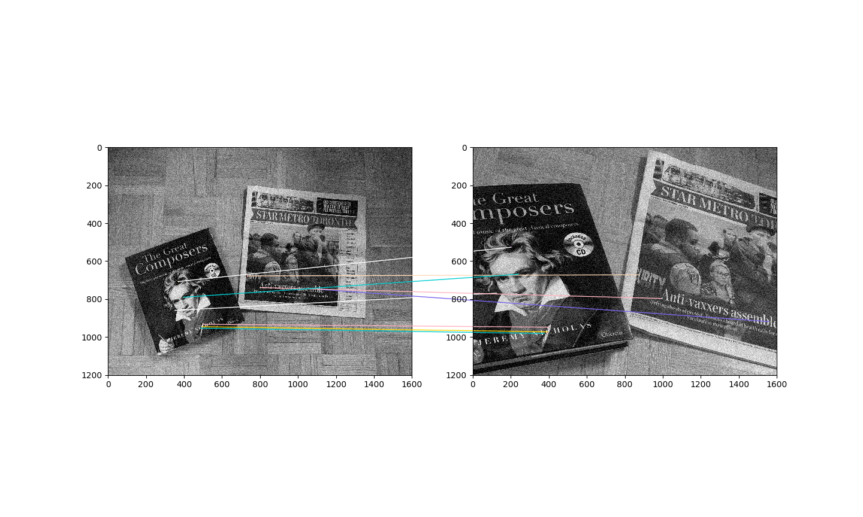

As you see, the noise decreased the number of matches we found, which is because during the keypoints detection, SIFT mistakenly treat many noises as keypoints, since they are similar to corners. Those wrong keypoints affect the judgement of matching as well. The less number of matches we have, the less matchings we can do.

Q4.(e).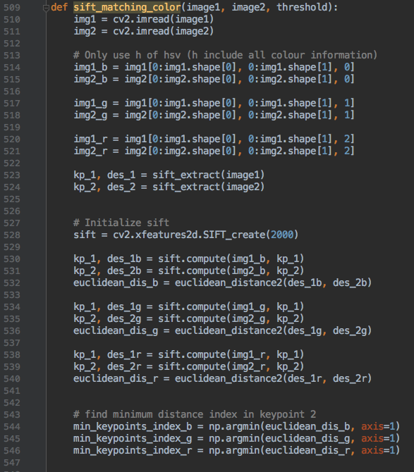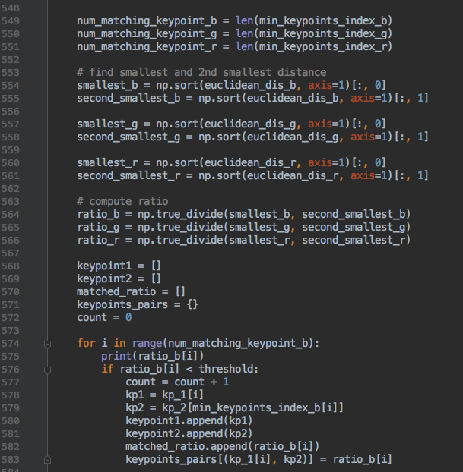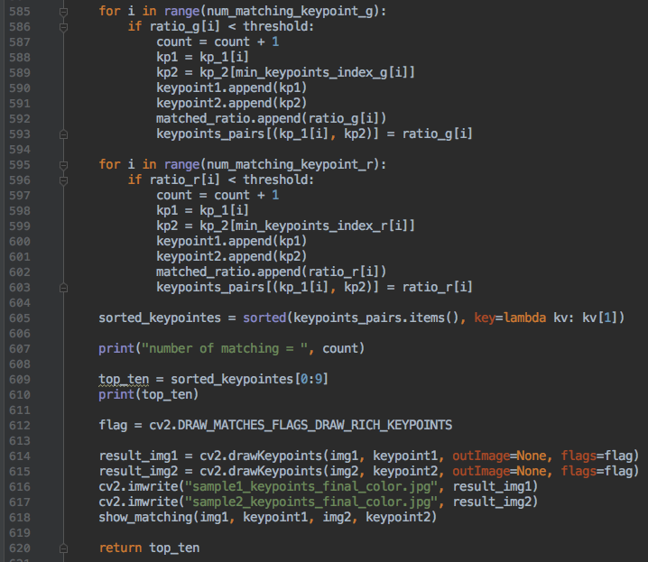

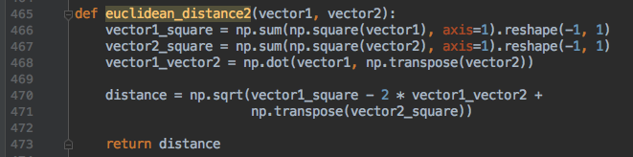

The algorithm is similar to Q4b, but with extra R, G, and B channels. Keypoints are extracted from grayscale image, then compute three descriptors separately from R, G, B channels. Then perform sift match on these three descriptors to calculate new matched keypoints.

Number of Matches (Please know, since the code execution on my laptop is very long for Q4, to make sure I can finish this assignment on time, I set the limitation as 2000 during sift initialization so that the running can be faster. The results of number of matches and the matching will be slightly less powerful than normal setting. However, the tendency is the same.):

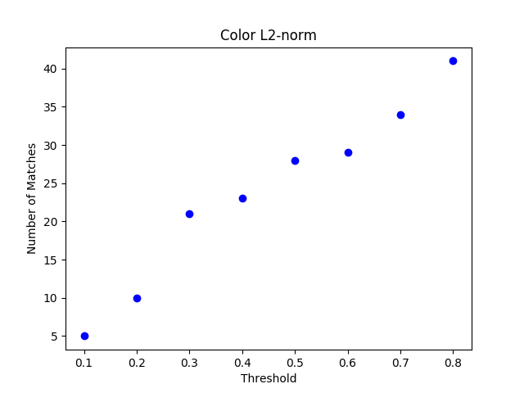

Top 10 matches at best threshold 0.8:

